



Business Requirement Document
Finance
NWS Tanker System
DOCUMENT FOR

Table of Contents:
Table of Contents: 1
1. Introduction 3
1.1 Business Need 3
1.2 Expected Business Outcomes 3
1.3 Project Scope Summary 3
2. Business Requirement Details 4
2.1 Requirement Description 4
2.2 Functional Requirements 5
2.3 Non-Functional Requirements 6
3. System Integration 6
4. Process Flow 7
4.1 Tanker Supplier Master 7
4.2 Tanker Transaction 7
4.3 Process Flow 8
5. Application Prototype 9
6. Open and Close Issues 11
6.1 Open Issues 11
6.2 Closed Issues 11

Document Control

Date | Author | Version | Change Reference
19-Oct-2025 | Mr. Vignesh Subramani | 1.0 | No Previous Version
Change Record

Reviewers
Name | Position
Mr. Parthasarathy | Project Manager, 4iapps, Oman

Approver
Name | Position | Signature
Mr. Yasser Mohamed Said Al Rawahi | Tanker Management Manager

Note to Holders:
If you receive an electronic copy of this document and print it out, please write your name on the equivalent of the cover page, for document control purposes.
If you receive a hard copy of this document, please write your name on the front cover, for document control purposes.

Introduction

1.1 Business Need
Nama Water Services currently operates the Tanker System in Custom OAF Page. Tanker System used to capture the Supplier master and transaction details related to tanker supplier for delivering the water to customers.

1.2 Expected Business Outcomes
- Create Supplier Master details with Supplier details, Bank Details, Contract Details, Capacity/Distribution Details, License Details, Contract Documents.
- Approval based on supplier master transaction for new records and for updates.

1.3 Project Scope Summary
The scope of this Application covers:
- Custom development of a Supplier Master and Transaction details.
- Approval workflow for the supplier master creation and updating.
- Transaction Creation and interfaced to Payables.
- Notification should be sent to payables team and ap distribution account should default based on Governate.

2. Business Requirement Details

2.1 Requirement Description
Tanker end users will create the supplier master data based on governate, wilayat. Each Header information has different titles like Supplier Details, Bank Details, Contract Details, Contract Attachment, Capacity/Distribution Details, License Details.
Supplier Details: Used to create supplier details for each governate, wilayat. Capturing the information related to suppliers.
Bank Details: Used to capture the bank information for the supplier. Attachment needs to be added.
Contract Details: Contract details like start date, end date, contract amount, vat percentage and other details captured.
Capacity/Distribution Details: Used to capture tanker capacity details.
License Details: To capture the license details with vehicle number and other information related to vehicle.
Once the Tanker supplier master is completed and approved. Users will create the transaction details. For each period based on the active supplier records the transaction will be created and once approved it will be interfaced to payables module.

2.2 Functional Requirements
Functional Requirement | Detailed Description
Supplier Details | Supplier information related to governate, wilayat, and other details. Approval will be required for each new and updating of suppliers.
Bank Details | Supplier bank details will be stored, and payment will be initiated with to the given bank account.
Contract Details | To maintain the contract details like start and end date, total contract amount, monthly payable amount. Add attachment related to contracts.
Capacity/Distribution Details | Tanker capacity details will be recorded.
License Details | To Capture the License information related to tanker vehicle.
Transaction | Used to enter the transaction details related to each supplier and approval will be sent to tanker system users.
AP Integration | Automatic AP Invoice creation in Oracle Fusion upon successful approved transaction from tanker system. AP Distribution account should default based on the governate.

2.3 Non-Functional Requirements
- System should support 100% availability.
- Page load response time under 3 seconds.
- Complete audit trail for every action and system integration log.

3. System Integration
System | Module | Integration Point
Oracle Fusion | Accounts Payable | Automatic AP Invoice creation in Oracle Fusion upon successful approved transaction from tanker system.

4. Process Flow

4.1 Tanker Supplier Master
1. Tanker Supplier master entered by the tanker end users.
2. Approver will review the master data and approve it.

4.2 Tanker Transaction
1. Transaction will be created based on the active supplier records from the tanker supplier master.
2. For each month transaction approval will be sent to Tanker Head.

4.3 Process Flow

5. Application Prototype
Supplier Master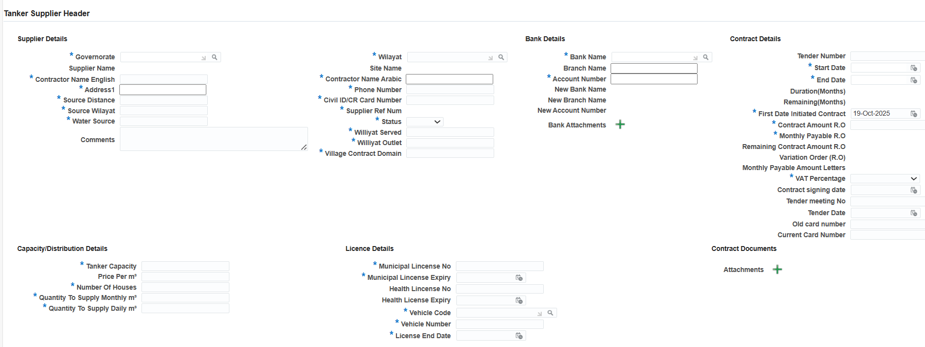

Tanker Transaction:
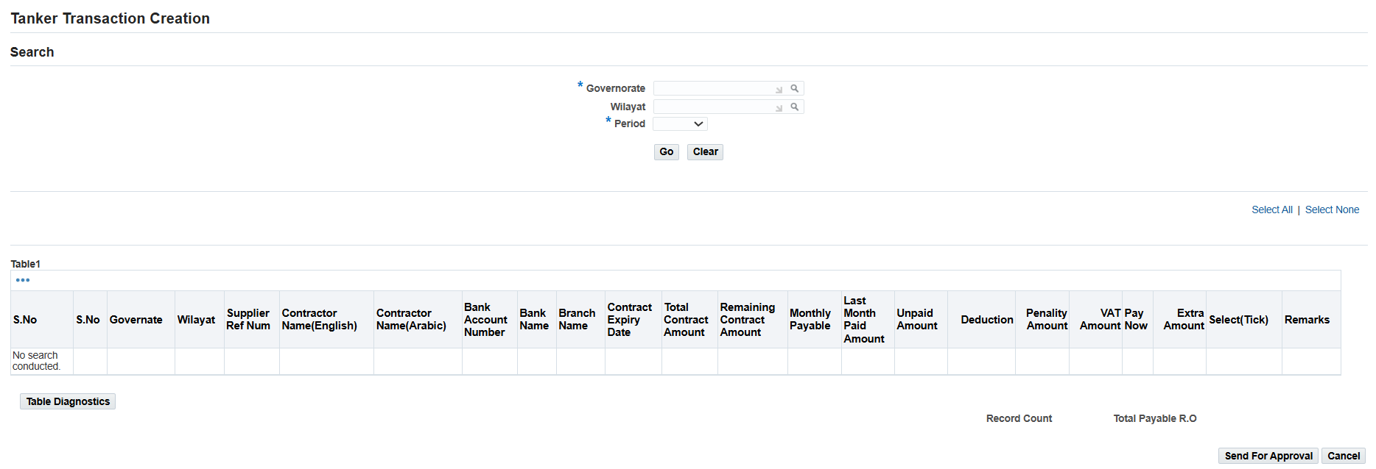

6. Open and Close Issues

6.1 Open Issues
S. No | Issue | Resolution | Responsibility | Target Date | Impact Date
1
2

6.2 Closed Issues
S. No | Issue | Resolution | Responsibility | Target Date | Impact Date
1
2

